Detailed Comments on the Wind Farm Guideline – Technical Supplement

Section | Details | Comment | Recommendations / Suggestions
Scoping Phase Requirements | The requirements for the scoping phase for Visual Impact is significantly reduced compared to current requirements. | Concern that visual impacts will be overstated through the desktop assessment. | - We recommend the simple assessment is undertaken at scoping phase (similar to the application of the preliminary assessment tools required for scoping phase of a solar farm project). This will help to manage expectations in the community on which dwelling receptors will require an assessment. It will also help to provide DPHI and the proponent gauge the number of dwellings requiring intermediate assessment.
 | Scoping phase no longer considers landscape character. | Important to have an understanding of the existing landscape character at an early stage to assist in guiding good design principles, protection of key landscape features and the existing landscape character on a broader scale as opposed to focusing on private receptors. | - AILA recommends that in addition to the viewshed mapping and distance thresholds, the scoping phase should include a high level landscape character analysis. This could be based on desktop assessment and would help to determine existing landscape character, public viewpoints and key landscape features to assist in good layout design outcomes early in the project.
Community engagement | Consultation requirements are to ne reconsidered. | Page 7. Technical Supplement: “The applicant must engage with the community, including the indigenous community, as early as possible and throughout the preparation of the assessment to verify the outcomes and to consult on any measures proposed to mitigate impacts.”  Page 10. “Engage with the community (including the indigenous community) local council and potential affected landowners as early as possible to identify and establish the importance of particular landscape values and characteristics.” | - Suggest the guideline does not include the need to undertake LVIA specific community engagement (including engagement with the indigenous community) from the LVIA guidelines and allocate to the appropriate community engagement / indigenous engagement guidelines.
Simple Assessment | Dwelling refinement during simple assessment phase. | When testing the simple assessment, AILA practitioners have noted a large majority of dwellings are requiring an intermediate assessment. | - Consider a higher magnitude threshold is considered for the simple assessment to further reduce dwellings requiring an intermediate assessment.
 | Presentation of the results of the simple assessment. | The example ‘simple assessment’ provided on page 57 is deemed unnecessary. If an intermediate assessment is required the results of the simple assessment are redundant. | - Recommend the results of the simple assessment are provided in a table form in the LCVIA (EIS Phase) not as per the example provided on page 57.
Intermediate Assessment | Presentation of the results of the simple assessment. | The example in the Technical Supplement show intermediate assessments for dwellings with moderate / high impacts are to be included in the EIS. | - It should be possible to include the results of the intermediate assessment ratings in a table and only include the intermediate assessment for low / very low ratings in the report.
Application of grid overlay to determine visual magnitude | The method for assessing visual magnitude (for both public domain and private dwelling impacts) using the grid overlay system appears to relate only to the visibility of the proposal. | The grid overlay system is a useful tool for refining dwellings down to determine those requiring an assessment, however there is concern the detail required for dwelling assessment using the visual magnitude tool overlaid onto a photomontage will present issues. | - AILA recommends that the assessment of visual magnitude allows for further consideration of the characteristics of the visible elements of the proposal (shape, line, colour etc.) and their compatibility with the character of the view. This will encourage design changes to reduce visual impact by means other than visual screening.
 | Variations in the number of occupied cells between project typologies, with Wind Farm Projects having the lowest thresholds. | The Technical Supplement states “This method is designed to weight vertical changes in magnitude more than horizontal changes. This reflects best practice understanding of visual impacts, including the concept that vertical changes to the field of view are perceived to be much greater or more impactful than horizontal changes.” – Page 18.  This contradicts the high magnitude calculations allowed for in application of the grid overlay for transmission line projects when compared with solar. A comparison in the visual magnitude ratings for transmission and wind are provided below. It is noted a variance of 10 occupied cells when comparing the ‘very high visual magnitude rating’ for a wind farm in comparison with a transmission project. | - AILA recommends the visual magnitude ratings are consistent across all project typologies, or further justification is provided in the Guidelines as to how the cell count has been formulated for each project type.
Comparison of visual magnitude thresholds:

Visual magnitude rating | Infrastructure type (Number of occupied cells)
 | Wind | Solar | Transmission
Very Low | 1-5 | 1-6 | 1-7
Low | 6-11 | 7-12 | 8-15
Moderate | 12-19 | 13-21 | 16-26
High | 20-27 | 22-30 | 27-37
Very High | 28+ | 31+ | 38 +

Landscape Sensitivity | Statement regarding the sensitivity of the landscape character type being defined by the ‘capability of the area to absorb changes’ is a concern.  Refer to page 14: “The sensitivity of the landscape character type should be rated based on the inherent capability of the area to absorb changes from the project”. | There is no methodology provided on how to gauge the level of a landscape character type being able to absorb change.  When considering the cumulative impact assessment is undertaken in the broader landscape character assessment, there is the potential for the area to ‘reach its capacity’ with multiple projects in the REZ and there is no definition for this limit. | - It is recommended that the reference to the capability of the landscape to absorb change be clearly defined.
Landscape character | The definition of landscape character and landscape values requires clarification. | There are a number of references to landscape values within the landscape character assessment.  Page 7. Landscape Character Impact assessment definition: the assessment of the potential impact on the areas cumulative built, natural and cultural character or sense of place…  This is the process for determining the overall impact of the project on area’s character and sense of place including what people think and feel about it and how society values it.  Page 10. 2.1 Baseline study. “This should be based on desktop analysis and field visits and should provide a descriptive and illustrative analysis of the qualities of the place, what makes it valued and any challenges that could arise in relation to the proposed development. | AILA recommend that DPHI differentiate between landscape character and landscape values. It is recommended DPHI apply the following (or similar) definitions:  Definition of Landscape Character  Landscape character is the distinct and recognizable pattern of elements that occurs consistently in a particular type of landscape. It reflects the unique combination of both natural and human factors that make one landscape different from another. This includes the physical elements like geology, soil, climate, flora and fauna, and the way these elements interact with each other. It also encompasses human influences such as historical, cultural, and economic activities that have shaped the land. Landscape character is an objective assessment of the physical and visual attributes of a landscape.  Definition of Landscape Values  Landscape values are the perceived, subjective qualities attributed to a landscape by individuals or communities. These values reflect the personal, cultural, social, and spiritual significance that a landscape holds for people. Landscape values are inherently subjective and can vary greatly among different observers or groups. Landscape values can include a wide range of perspectives, such as aesthetic appreciation, cultural heritage significance, recreational enjoyment, spiritual connection, or ecological importance.
Assessment of Impacts on Landscape Character | Lack of methodology for assessment of impacts on landscape character. | The Technical Supplement provides detailed methodologies for determining visual magnitude levels on individual receptors, however there is a lack of methodology provided to determined magnitude on landscape character. | - Recommend the Technical Supplement provides examples of low, moderate and high visual magnitude on broader landscape character units.
Viewpoint Sensitivity | Inconsistences in the viewpoint sensitivity levels across project typologies. | There are inconsistencies in the viewpoint sensitivity levels. An example of the difference between wind energy and transmission guidelines are presented below: | - Recommend viewpoint sensitivities are consistent across all project typologies.
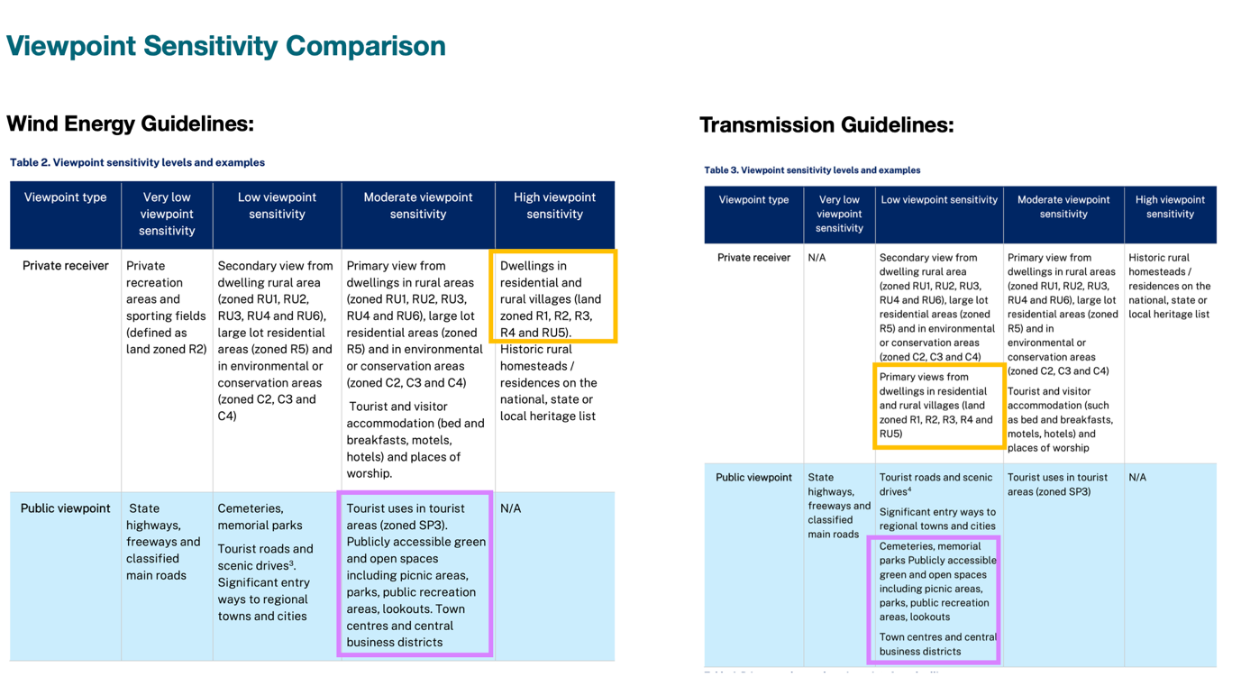

Night Lighting | The Draft Wind Energy Guidelines have no guidance for the assessment of aviation hazard lighting or night lighting. | Night lighting is often a concern raised by the community.  The Draft Wind Energy Guidelines have no requirement for the assessment of night lighting stating … “The visual impact assessment process will consider the worst-case view of a project during the day. Whether or not the turbines have lighting is unlikely to change the impact assessment rating or whether mitigation is required. Consequently, a separate night-lighting assessment is not required for individual viewpoints. An example of the effects of lighting during the evening and night is provided in Figure 6”. (Page 28)  However, the Technical Supplement says … “Where aviation hazard lighting is proposed, the magnitude and impacts of the lighting should also be considered in the landscape character assessment” (Page 14).  There is also a mention of mitigation of lighting in the Technical Supplement on page 26: “vegetation screening, or the planting of trees and shrubs, may be a useful option to visually screen wind energy developments or other potential visual impacts (such as night lighting).” | AILA recommend guidance around the expectation for the assessment of aviation lighting and ancillary lighting.
Shadow Flicker Assessment |  | Shadow Flicker is addressed in the Draft Wind Energy Guideline. | Shadow Flicker is addressed in the Draft Wind Energy Guideline. Consider inclusion of guidance on how to mitigate residual impacts of shadow flicker in the Technical Supplement.
Dwelling Assessment | It is anticipated the methodology in the Technical Supplement will result in a high number of detailed dwelling assessments. Accessing private properties can be a difficult task. | Appendix D of the Wind Farm Technical Supplement states: “Applicants should use best endeavours to obtain permission to access private property for the purpose of preparing photomontages. However, if the applicant is unable to obtain access, then it may use one of the following alternatives…” | The guidance needs to provide clarification around how access is requested and the number of attempts made to gain access to private property. For example it could be possible to suggest that once a defined number of attempts to gain access have been made, a set timeframe (e.g. 1 month) starts and landowners can reach out for an assessment.  Recommend clarity in the Technical Supplement that if access is not granted, then assumptions around the orientation of the dwelling vegetation etc. will need to be made. It should not benefit the landowner if they do not provide access.  Guidance also needs to be included to clarify the reasonable maximum number of times that an LVIA practitioner is expected to visit an area to obtain private views (i.e. to avoid situations where different community members will permit access at different times of the week/weekend, day/evening, month/year that would result in an untenable number of visits, particularly in more remote locations).  If safety is ever a concern, it should be clear that the consultant / developer does not need to visit the location and should be able to use desktop analysis to assess the dwelling.
 | Further clarification is required on acceptable assessment location. | Page 8 statement relating to the acceptable location of the assessment still presents ambiguity:  ‘The assessment must focus only on views from the dwelling and not from the property boundary or any other parts of the property. Furthermore, the assessment should consider the potential worst-case views that have the greatest potential to impact on the residential amenity. Residential amenity encompasses the overall quality, experience and nature of views and outlooks available to occupants of a dwelling and its immediate surrounds including pool areas and gardens.’ | Guidance is required on acceptable photograph locations for representative views from dwellings. Confirming that this is to be determined by the visual assessor, not the landowner.  Noting, that AILA LVIA practitioners are often asked to take photographs from multiple locations, regardless of their usefulness in the assessment. We are then criticised for not assessing and presenting all views in the assessment. This needs to be clear for the assessor and the community.  Recommend some photographic examples or a plan for ‘acceptable’ photo locations. This can be selected in consultation with the landowner but it needs to be clear that the main purpose is to understand impacts from the dwelling, not a driveway, fence line etc.
Public Viewpoint Assessment | Public viewpoints are required for assessment. | No guidance is provided on what public viewpoints are required to be assessed.  Theoretically, in the absence of screening vegetation / landform every location along a road could be considered a viewpoint. It would be more appropriate to request identification of key / representative public viewpoints. Significant public viewpoints should be considered to at least the same extent as private viewpoints. | - Clarification is required on what public viewpoints are required to be assessed. We suggest these should include a reasonable and representative selection of locations such as rest areas, parks and recreation facilities, select locations on scenic routes, key road intersections, town centres (for example church, main street or town hall), cemeteries etc.
Mitigation measures | Mitigation measures on landscape character | In regards to mitigation of impacts on the landscape character the Technical Supplement states (Page 13): “Where impacts are expected to be high, the assessment should propose measures to avoid or mitigate these impacts including re-siting and re-sizing elements of the Project. Any significant residual impacts on the landscape remaining after mitigation should then be summarised in the final step of the process”. | Consideration of good design principles be included in the Technical Supplement to drive good design.  For example, there are design principles provided in the Scottish Natural Heritage Guidance ‘Siting and Designing Wind Farms in the Landscape’ (2017): https://www.nature.scot/sites/default/files/2017-11/Siting%20and%20designing%20windfarms%20in%20the%20landscape%20-%20version%203a.pdf
 | Mitigation measures are not project specific | The mitigation measures proposed for Wind Farms are the same as for Solar Energy Projects, i.e. preparation of a landscape plan, species selection etc. This should be revised to acknowledge the needs for different projects.  On a solar energy project, for example, the preparation of a landscape plan contained within the project site is suitable. Whereas, for wind farm and transmission projects, where landscape mitigation is more likely to be on neighbouring private property, different approaches should apply. | An emphasis should be placed on at receiver mitigation as (unlike solar farms) wind farm projects may require at-receiver mitigation to successfully mitigate the project in a number of cases.  For private property view impacts, mitigation measures should be connected to impact ratings to allow certainty. AILA does not support the conditioning of projects to mitigate all visibility regardless of impact level on private property.
 | Verification of landscape screening. | The technical supplement includes references to verifying if the mitigation measures will screen views. Due to the many variables beyond the control of the LVIA consultant at the impact assessment stage, verification of screening success presents an unrealistic burden with potential legal ramifications to consultants that will not be acceptable to AILA members’ insurers. | Successful establishment and on-going management of screening vegetation is best suited to an operational commitment and therefore it is recommended this is detailed in the Project’s Environmental Management Plan or Vegetation Management Plan with appropriate monitoring and performance parameters.
 | Re-siting / Resizing turbines | In addition to landscape screening to mitigate residual impacts, page 14 states: ‘Where impacts are expected to be high, the assessment should propose measures to avoid or mitigate these impacts including re-siting and re-sizing elements of the project. | Re-sizing of turbines is not generally a viable option for mitigating impacts on the broader landscape for most wind farm projects. The introduction of the turbine into the landscape is the key change, the reduction in turbine size will not typically reduce the impact.
Cumulative Visual Impacts | Limited methodology for cumulative assessment of visual impacts | The Technical Supplements lack direction on how to assess cumulative visual impacts. For example, in the Wind Farm Technical Supplement, at page 10. “The level of assessment should be appropriate for the context in which the development is proposed and should be proportionate to the likely impacts, including cumulative impacts, of the development”.  There is an example provided (refer page 46) of the grid overlay tool to assess cumulative visual magnitude.  There are many variables when assessing cumulative impacts. Design layouts change, accurate data for proposed developments nearby is not always readily available (or in the public domain) and applying the level of detail required in the grid overlay may prove to be a difficult process that will require multiple iterations. | Greater clarity around the methodology for cumulative impact needs to be provided. In REZs, consideration should be given to the implicit expectation that the character of these areas will change. These are issues of consultation and engagement that should not be part of individual LVIAs but should form part of the broader consultation and engagement undertaken by the Project proponent.  Design principles for addressing impacts on the broader landscape character would be useful.

